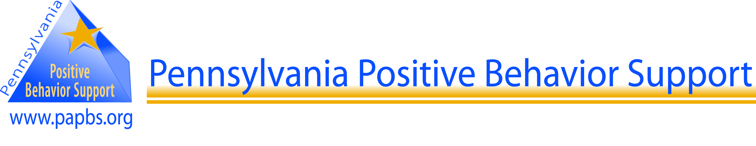

**Coaches’ Curriculum Overview**

Fall 2011

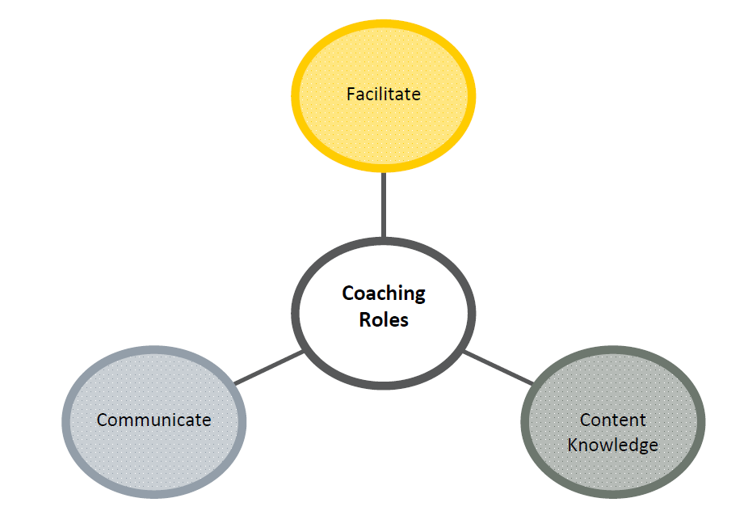

Content and materials contained in this staff development curriculum are provided by the many outstanding members of the greater PBIS community and adapted from pbis.org and flpbs.fmhi.usf.edu

***Coaches’ Curriculum Overview***

***Table of Contents***

**Letter 3**

**Welcome and Introduction 4-5**

**Resources (Acronyms and Websites) 6**

**Roles and Responsibilities 7**

**FAQ 8-9**

**Coaching Essentials Questionnaire 10**



Dear Potential School-wide PBIS Coach,

You have been identified by either your school administration or the School-wide Positive Behavior Interventions and Support (SWPBIS) District Coordinator as a potential SWPBIS Coach. Included in this packet you will find information providing you with a brief overview of what Positive Behavior Interventions and Support is, the roles and responsibilities of a PBIS Coach, and some additional tips on assisting teams in working collaboratively. The District Coordinator may be contacting you to set up a meeting to review this packet and discuss your interest in participating. You can also go to our website at http://www.papbs.org to learn more about Pennsylvania’s PBIS Network. Your local SWPBIS Facilitator will be contacting you to discuss future training opportunities.

Included in this packet are 9 sections which include the following:

* Section 1: Table of Contents
* Section 2: Coaches’ Curriculum Overview
* Sections 3-8: Coaches’ PowerPoints and Resources
  + Coaching: The Basics PowerPoint and Workbook
  + Coaching 101 PowerPoint
  + Team Initiated Problem Solving (TIPS) PowerPoint and Handbook
  + Appendices
* Section 9: PBIS Assessments
  + PBIS Assessment Overview
  + Evaluation Plan FY2011-12
  + PBIS Assessments

Sincerely,

Pennsylvania’s PBS Network

www.papbs.org

**Welcome to the Pennsylvania PBS Network!**

The Coaches Curriculum is designed to provide guidelines, procedures and strategies for developing your School-Wide Positive Behavior Support Plan. It provides a basis to start from; as a beginning to your building-wide implementation. Please add documents to your manual as you attend additional trainings and implement successful strategies in your building.

We will make this manual available online in the near future. As updates and additions are created, look for them at [www.papbs.org](http://www.papbs.org).

**What is Positive Behavior Interventions and Supports (PBIS)?**  
Positive Behavior Interventions and Supports is an evidence-based, cost-effective, systems approach for establishing the social culture needed for schools to be effective learning environments for all students. Positive Behavior Interventions and Supports eliminates barriers to learning, creates and maintains a safe and effective learning environment in schools, and ensures that all students have the social and emotional skills needed to succeed in school and beyond. Positive Behavior Interventions and Supports helps schools teach students expected behaviors and social skills, creates student behavioral health and academic support systems, and applies data-based decision-making to discipline, academics, and social/emotional learning. Positive Behavior Interventions and Supports uses the three-tiered approach of universal interventions (for all students and settings), secondary interventions (for students who are at-risk), and tertiary interventions (for individual students needing specialized assistance).

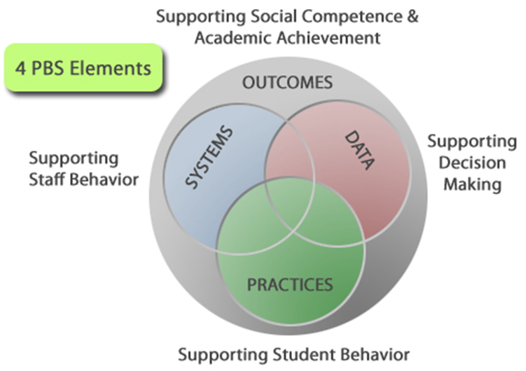

**The Pennsylvania Positive Behavior Support Network:**  
The mission of the Pennsylvania Positive Behavior Support Network (PAPBS Network), through training and technical assistance, is to support schools and their family and community partners to create and sustain comprehensive, school-based behavioral health support systems in order to promote the academic, social and emotional well-being of all Pennsylvania’s students. The network’s goal is to ensure that all schools have the necessary technical assistance, collaborative opportunities, and evaluative tools needed to overcome non-academic barriers to learning and achieve competence and confidence in advancing academic, social, and emotional success for all students.

**Goals and Objectives**

The goal of the PAPBS Network is to ensure that all schools have the necessary technical assistance, collaborative opportunities, and evaluative tools needed to overcome non-academic barriers to learning and achieve competence and confidence in advancing academic, social, and emotional success for all students. In order to achieve this goal the PAPBS Network has identified the following objectives:

* Develop and implement a school-wide cross-system approach for supporting the academic and emotional well-being of all students using research-based positive behavioral supports and strategies of varying intensity: 1) universal or preventative strategies for the benefit of all students; 2) secondary strategies for those who will achieve with enhanced supports; and 3) tertiary or intensive services for those who will achieve with intensive and coordinated supports.
* Achieve sustainability by seeking funding and legislative support for demonstration models, providing training and technical assistance, and encouraging the facilitation of collaborative partnerships among schools, families, youth and agencies.
* Foster a consistent application of best practice standards among schools, families and agencies.
* Promote shared values that are consistently demonstrated through practice and partnerships of schools, agencies and families.
* Develop and embed opportunities for collaboration between systems partners and families.
* Establish a dialogue that will inform ongoing training needs.
* Reduce fragmentation of training resources.
* Conduct cross-systems professional development to ensure a common language, knowledge base, and understanding of supports and services available to children, youth and families.
* Develop a cross-systems/integrated planning process for individual child/family needs.
* Develop a cross-systems progress monitoring/data collection system to ensure accountability to the academic achievement and well-being of all children, youth and families.
* Ensure that youth and families will have opportunities for meaningful participation in all PAPBS Network activities, including the development, provision and monitoring of services, policies and procedures.

**State Leadership Team (SLT)**

**The PA PBS State Leadership Team (SLT) is a school-based behavioral health community of practice that oversees the PAPBS Network. The following agencies are represented on the SLT:**

**Pennsylvania Training and Technical Assistance Network (PaTTAN)**

**Bureau of Special Education**

**Bureau of Teaching and Learning Support; Division of School Options and Safety**

**Pennsylvania Governor’s Commission on Children and Families**

**Pennsylvania Youth and Family Training Institute**

**Pennsylvania Network for Student Assistance Professionals**

**Pennsylvania Student Assistance Program (SAP)**

**Community Care Behavioral health**

**Education Law Center**

**Value Behavioral Health**

**Devereux Center for Effective Schools**

**PA Department of Health, Bureau of Drug and Alcohol Programs**

**Disability Rights Network of PA**

**PA Community Providers Association**

**Juvenile Court Judges’ Commission**

**Department of Public Welfare, Office of Mental Health and Substance Abuse Services**

**Allegheny Department of Human Services**

**Mental Health Association of Pennsylvania**

***Resources***

|  |  |
| --- | --- |
| **BAT** | **Benchmarks for Advanced Tiers** |
| **BEP** | **Behavior Education Program** |
| **BOQ** | **Benchmarks of Quality** |
| **CICO** | **Check-in Check-Out** |
| **CnC** | **Check n Connect** |
| **EBD** | **Emotional Behavioral Disorder** |
| **EBS** | **Effective Behavioral Support** |
| **EC/IC** | **External Coach/Internal Coach** (now called Building/District Coaches) |
| **FBA** | **Functional Behavioral Assessment** |
| **ILI** | **Initial Line of Inquiry** |
| **ISS** | **In-School Suspension** |
| **ODR** | **Office Discipline Referral** |
| **OSS** | **Out-of-School Suspension** |
| **PAPBS** | **Pennsylvania Positive Behavior Support Network** |
| **PBIS** | **Positive Behavioral Interventions and Support** |
| **PIC** | **PBS Implementation Checklist** |
| **POI** | **Phases of Implementation** |
| **SAP** | **Student Assistance Program** |
| **SAS** | **Self Assessment Survey** |
| **SCT** | **State Coordinators’ Team** (PaTTAN Behavior Leads and representative from the State Leadership Team – Dept. of Public Welfare, Community Care Behavioral Health, Devereux and EITA) |
| **SET** | **School-wide Evaluation Tool** |
| **SLT** | **State Leadership Team** (School-Based Behavioral Health Community of Practice that oversees the PAPBS Network) |
| **SSS** | **School Safety Survey** |
| **SWF** | **School-wide Facilitators** (IU TAC) |
| **SWIS** | **School-Wide Information System** (cost: $250.00/building; $50/building for CICO) |
| **SWPBS** | **School-wide Positive Behavior Support** |
| **TIC** | **Team Implementation Checklist** (being replaced by PIC) |
| **TIPS** | **Team Initiated Problem Solving** |

|  |  |
| --- | --- |
| [**http://www.cber.org/**](http://www.cber.org/) | **Center for Behavioral Education and Research** |
| [**http://flpbs.fmhi.usf.edu/**](http://flpbs.fmhi.usf.edu/) | **Florida’s Positive Behavior Support Project** |
| [**http://www.pbisillinois.org/**](http://www.pbisillinois.org/) | **Illinois PBIS Network** |
| [**www.papbs.org**](http://www.papbs.org) | **PA PBS Network** |
| [**www.pbis.org**](http://www.pbis.org) | **OSEP Technical Assistance Center on Positive Behavioral Interventions and Support** |
| [**www.pbisassessment.org**](http://www.pbisassessment.org) | **PBIS Assessment** (web-based application designed to assist in high-fidelity, sustained implementation of SWPBS) |
| [**http://pbiscompendium.ssd.k12.mo.us/index.htm**](http://pbiscompendium.ssd.k12.mo.us/index.htm) | **The PBIS Compendium** (a collection of resources from the PBIS Facilitators of the Special School District of St. Louis County) |
| [**http://www.scalingup.org/**](http://www.scalingup.org/) | **State Implementation & Scaling-up of Evidence-based Practices** |
| [**www.swis.org**](http://www.swis.org) | **School-Wide Information System** (web-based information system for gathering, entering, summarizing, reporting and using office discipline referral information) |
| [**www.uoecs.org**](http://www.uoecs.org) | **University of Oregon, Education and Community Supports** |

***Coaches’ Roles and Responsibilities***

**Why Coaching?**

In SWPBS, coaching plays a very important role: it builds internal capacity (within the school and district) to prevent many of the problems associated with training in isolation.

**Coaching Pre-requisites: What is Needed to Begin Coaching?**

* Fluency with knowledge & use of PBS concepts
* District endorsement
* Agreement to work with a school leadership team that is committed to completing the 3-day School-wide PBS Training
* Agreement to collaborate with and meet within the district for monthly Coaches' Meetings
* Agreement to collaborate with and meet regionally at least once per year with others in a coaching/facilitation role (for state-wide PAPBS Training)
* Demonstrated experience capacity to problem solve, collaborate, communicate, etc. with adults

**Basic Coaching Skills Requirements:**

* Experience conducting small group skill training sessions with adults.
* Familiarity with typical classroom and school structures, operations, policies, etc.
* Familiarity with general discipline, classroom, behavior and instructional management, and curriculum
* History of consistent, accurate, and effective follow through with commitments
* Experiences working with individuals or groups from diverse backgrounds (e.g., parents, students, agency representatives, community members, educators)
* Experience with facilitating team meetings
* 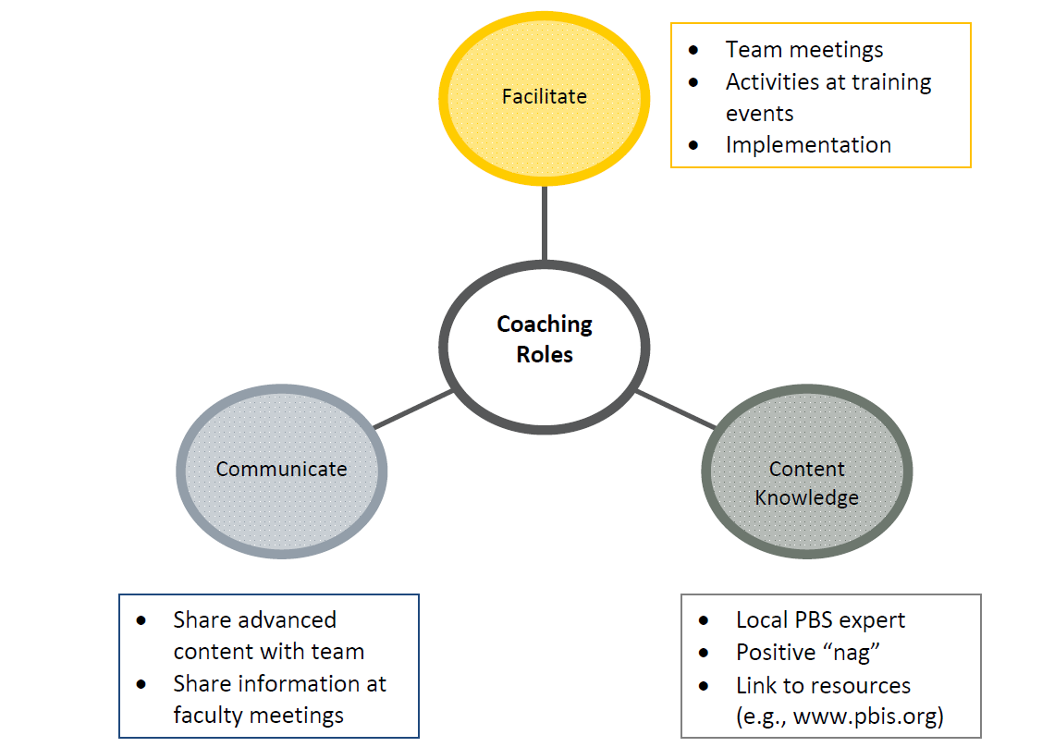Rudimentary computer hardware and software skills

***Frequently Asked Questions***

**What is PBIS?**

Positive Behavior Interventions and Supports is an evidence-based, cost-effective, systems approach for establishing the social culture needed for schools to be effective learning environments for all students. Positive Behavior Interventions and Supports eliminates barriers to learning, creates and maintains a safe and effective learning environment in schools, and ensures that all students have the social and emotional skills needed to succeed in school and beyond. Positive Behavior Interventions and Supports helps schools teach students expected behaviors and social skills, creates student behavioral health and academic support systems, and applies data-based decision-making to discipline, academics, and social/emotional learning. Positive Behavior Interventions and Supports uses the three-tiered approach of universal interventions (for all students and settings), secondary interventions (for students who are at-risk), and tertiary interventions (for individual students needing specialized assistance).

**How is PBIS a process?**

PBIS is not a packaged program with a set script. There are critical components that comprise the entire process. The components are individualized to meet the specific needs of each school. Additionally, the components are always changing to meet the specific needs of the school (e.g., population changes, maintain interest, address multiple levels of inappropriate behavior, etc.).

**How is PBIS proactive?**

The team uses discipline data to identify patterns and possible causes of inappropriate behavior. This information is then used to develop effective interventions to decrease inappropriate behavior and increase desired behavior across campus. The use of yearly, monthly, or more frequent data comparisons helps to prevent the same patterns of inappropriate behavior from reoccurring and assist the core team in adapting the school-wide PBIS plan.

**How is PBIS educative?**

Students in our schools come from many different backgrounds and cultures that view “behavior” differently; thus, we cannot *assume* that students know how to behave appropriately when at school. Furthermore, many of our students are making poor choices when confronted with a conflict. Consequently, we must teach our students how to behave at school to ensure that they do make better choices. PBIS views inappropriate behavior in the same manner that problems in reading or math are viewed…as a skill deficit. When a skill deficit exists, we must teach the appropriate skill. By doing so, a unified and positive school climate forms informing students and staff that appropriate behavior is a priority in school.

**How is PBIS functional?**

Students engage in inappropriate behavior to obtain something they want (e.g., attention, getting out of an assignment, etc...); thus, it serves a purpose for them. PBIS uses the function of the inappropriate behavior to identify an appropriate consequence and avoid rewarding the misbehavior.

**What does PBIS look like at school?**

* Discipline DATA are used to help track progress and identify areas to target for intervention
* CONSISTENT discipline referral PROCESSES & PROCEDURES exist throughout the school
* Use of school-wide EXPECTATIONS & RULES in specific settings to TEACH students appropriate behavior
* A REWARD SYSTEM to encourage appropriate behavior and EFFECTIVE CONSEQUENCES to discourage inappropriate behavior

**How long will it take to implement PBIS?**

Because school-wide PBIS is a process, not a program, the length of time it takes to get started varies by school. Schools typically take between 3 months to 1 year to fully implement all the critical components of PBIS. Components are generally introduced a few at a time. The process is ongoing and constantly adapted to meet the changing needs of the school and to address current concerns. Many schools begin noticing improvements right away. However, it may take a few years for the school’s philosophy regarding the handling of inappropriate behavior to change.

**How will this affect me?**

Faculty and staff must decide if positive behavior support is a good fit for their school. Once the school obtains an 80% approval rate from faculty and staff (must include administration), the core team begins brainstorming and working on each of the critical components of PBIS. Faculty, staff and students are asked for input/feedback on all components and to contribute to the overall school-wide PBIS plan. All members of the school are participants in positive behavior support and adhere to the school-wide expectations.

**Popular Myths regarding PBIS**

**“The *positive* in Positive Behavior Support means we give out rewards”**

The *positive* refers to a change in focus from reactive (focusing on what students do wrong) to proactive (teaching and recognizing what students do right). It refers to an overall change in the school climate to a learning environment where students and teachers feel appreciated, safe, and respected. Rewards are used to assist staff in focusing on the positive and to assist students in making better choices.

**“We will no longer punish students for inappropriate behavior”**

PBIS does not ignore inappropriate behavior. Consequences are more than “punishment” and serve to either increase or decrease inappropriate behavior. PBIS views appropriate consequences as those that are effective in changing the student’s inappropriate behavior. Schools develop a plan for inappropriate behavior that matches consequences to the severity of the inappropriate behavior in order to maintain consistency across campus.

**“PBIS uses bribes to get students to behave”**

Using a reward system is not bribing a student to behave appropriately. A bribe occurs when something is offered to a person before the behavior to get them to behave in a specific way. PBIS acknowledges and rewards students for following school-wide expectations and rules after the behavior occurs. Thus, rewards are *earned*, not offered as payoff in exchange for good behavior.

***Coaching Essentials Questionnaire***

**Basic Coaching Skills Requirements:**

|  |  |  |
| --- | --- | --- |
|  | **Yes** | **No** |
| Experience conducting small group skill training sessions with adults |  |  |
| Familiarity with typical classroom and school structures, operations, policies, etc. |  |  |
| Familiarity with general discipline, classroom, behavior and instructional management, and curriculum |  |  |
| History of consistent, accurate, and effective follow through with commitments |  |  |
| Experiences working with individuals or groups from diverse backgrounds (e.g., parents, students, agency representatives, community members, educators) |  |  |
| Experience with facilitating team meetings |  |  |
| Basic computer hardware and software skills |  |  |

**Coaching Pre-Requisites: What is Needed to Begin Coaching?**

|  |  |  |
| --- | --- | --- |
|  | **Yes** | **No** |
| Awareness of PBS concepts |  |  |
| District endorsement |  |  |
| Agreement to attend all days of the School-wide PBS Training with school team |  |  |
| Agreement to work with school PBS Team including attending monthly meetings |  |  |
| Agreement to collaborate with and meet within the district for monthly Coaches’ Meetings (if applicable) |  |  |
| Agreement to collaborate with and meet regionally with others in a coaching/facilitation role |  |  |
| Demonstrated experience/capacity to problem solve, collaborate, communicate, etc. with adults |  |  |