**Indicator 13 File Upload LEA**

LEAs that are not in IEP Writer or are not allowing the sharing of files with Indicator 13 will need to create a Student/Teacher CSV file to be uploaded to the Indicator 13 system. Please reference the file format below.

CSV Layout

|  |  |  |  |  |  |  |
| --- | --- | --- | --- | --- | --- | --- |
| Teacher Last Name | Teacher First Name | Teacher Email | Student ID | Student Last Name | Student First Name | * |

Once the Student/Teacher file has been created the LEA will log into the Indicator 13 site via the username and password they were provided.

<https://apps.leaderservices.com/_Ind13/index.aspx>

After the LEA has logged in the screen below will be displayed. Please click the “Student/Teacher File Upload” button to begin the Student/Teacher file upload.

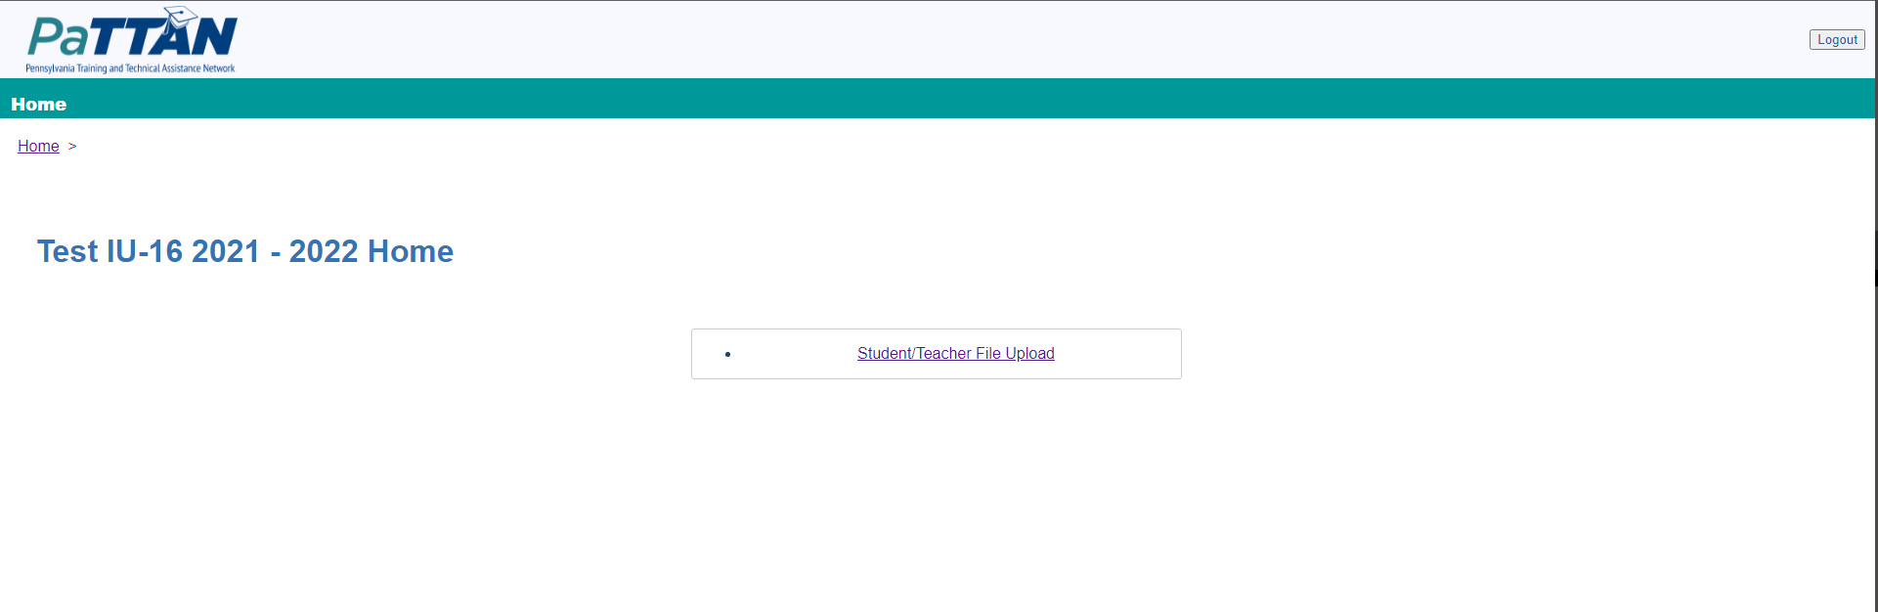

After clicking the “Student/Teacher File Upload” button the below screen will be displayed. Please click the “Choose File” button which will open a popup allowing the LEA to select the Student/Teacher CSV File.

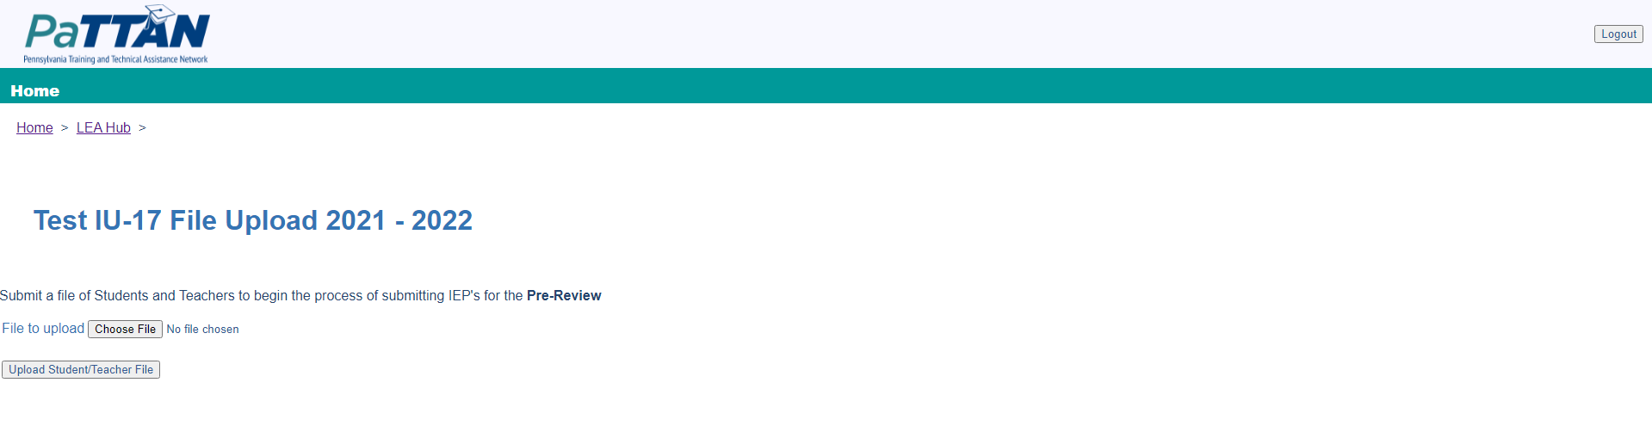

Once the Student/Teacher CSV File is selected the name of the file will show next to the “Choose File Button”. Please click the “Upload Student/Teacher File” button to upload the selected file. After the file has been uploaded the system will display the screen show below with the teachers from the Student/Teacher File and the randomly selected students.

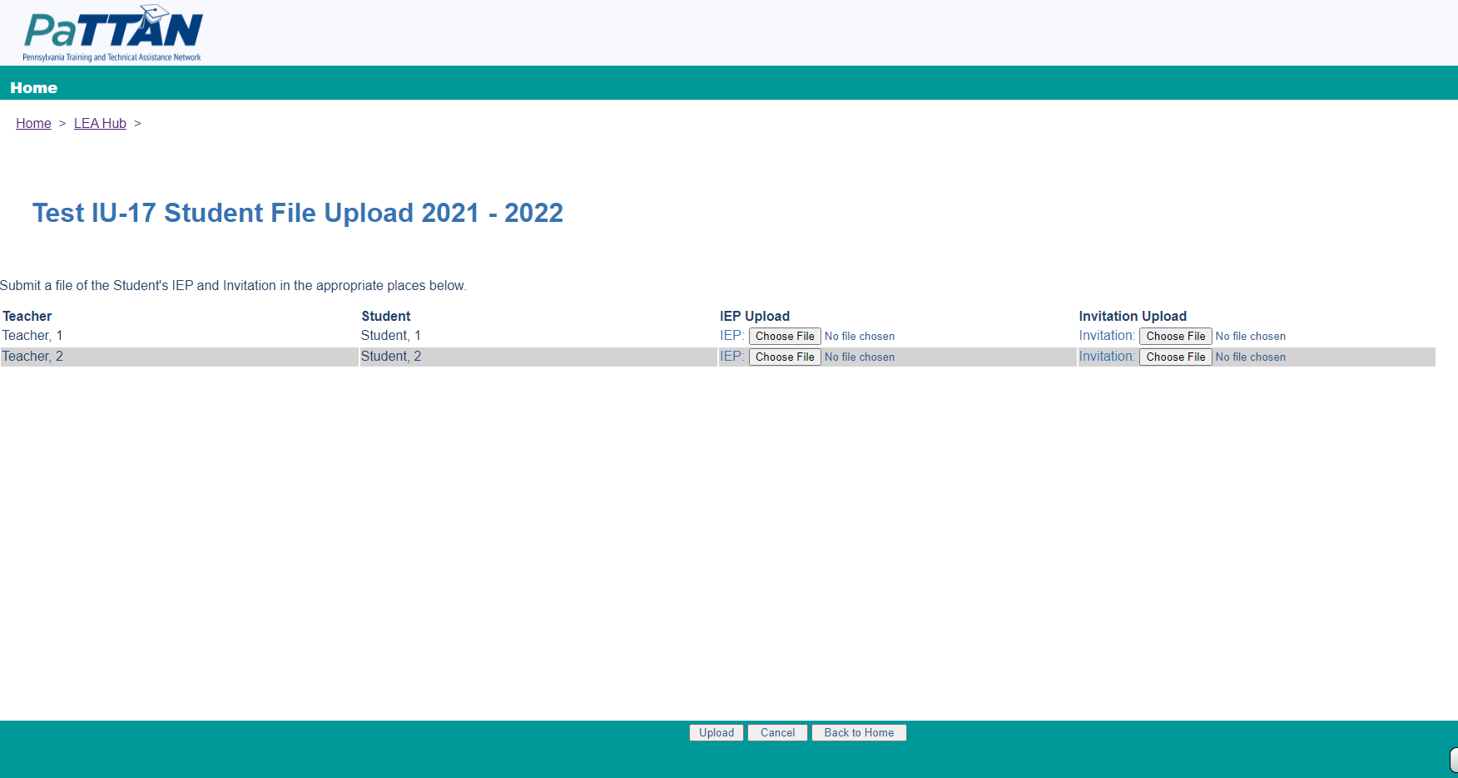

Please click the “Choose File” Button for each of the students for both the IEP and Invitation and select the corresponding file. Once all files have been added click the “Upload” Button at the bottom of the page to submit the files. After submitting the files the actions required by the LEA are completed for that review. If this was the pre review the system will display a message “Please come back on February 1st to begin uploading files for the Post-Review.”.

If this was the post review the system will display the message “The Pre and Post Review IEPs and Invitations have been submitted for the current school year.”

Once the LEA file submission is completed the system will generate a blank Indicator 13 checklist record for each student with the files attached. The IU Tac can then view the records and files within the system.